Final Examination EECE 492: Name:___Joesphan Lu__

You may not give or receive assistance on this examination. Cheating will result in a failing grade and referral for disciplinary action. If you have any uncertainty about a question, write a note in the margins of the examination and do your best to answer the question.

The images below show a PCB design (top and bottom) with a few non-ideal PCB board routing issues. Circle as many non-ideal routing elements you can find. (20 pts)

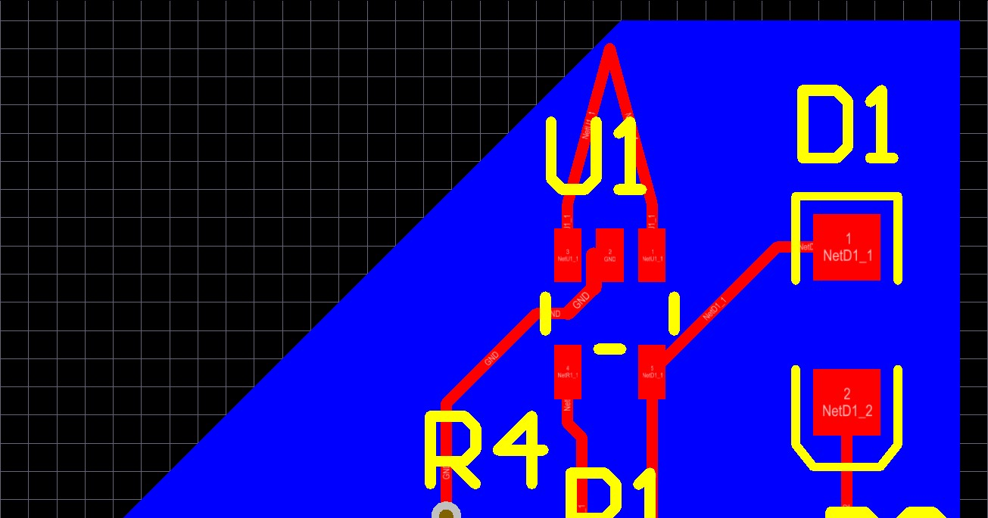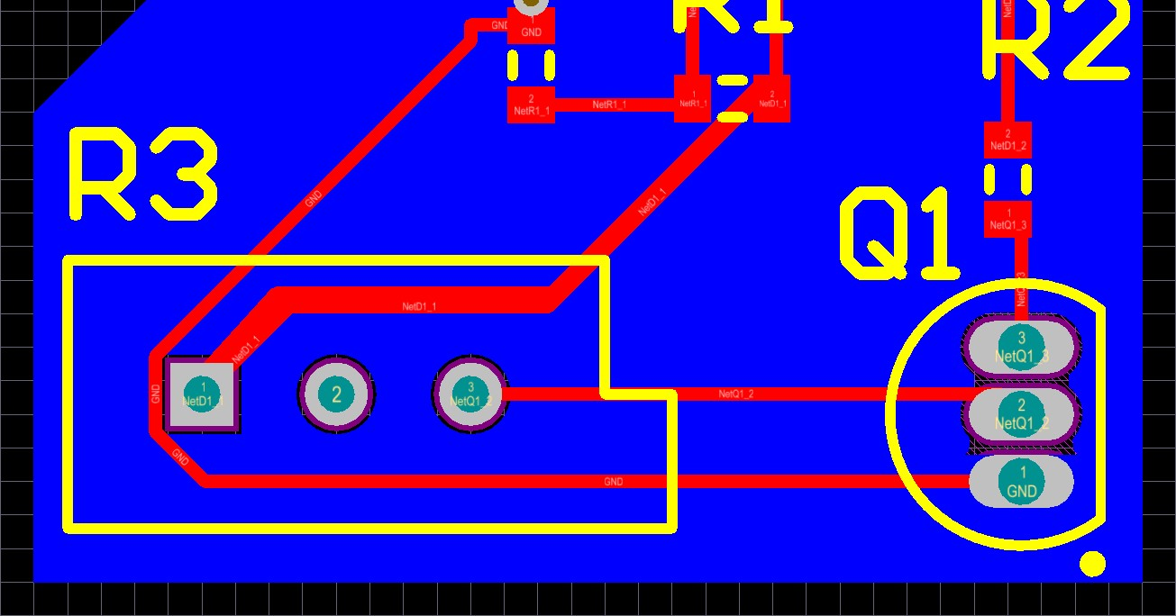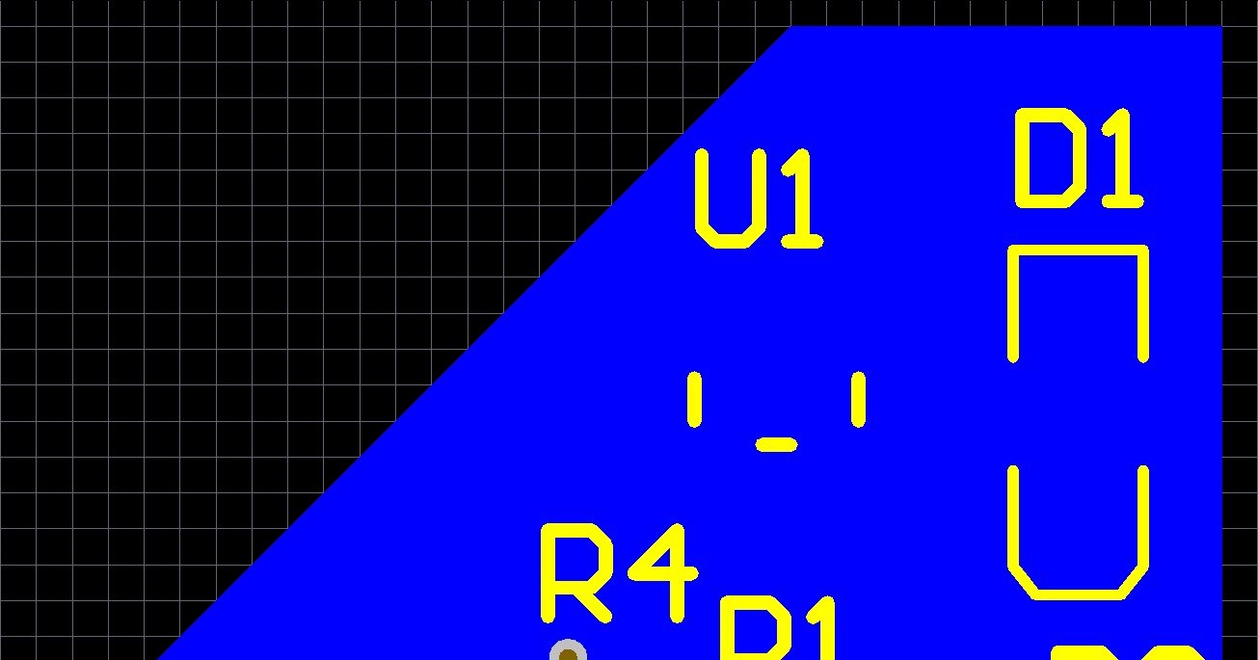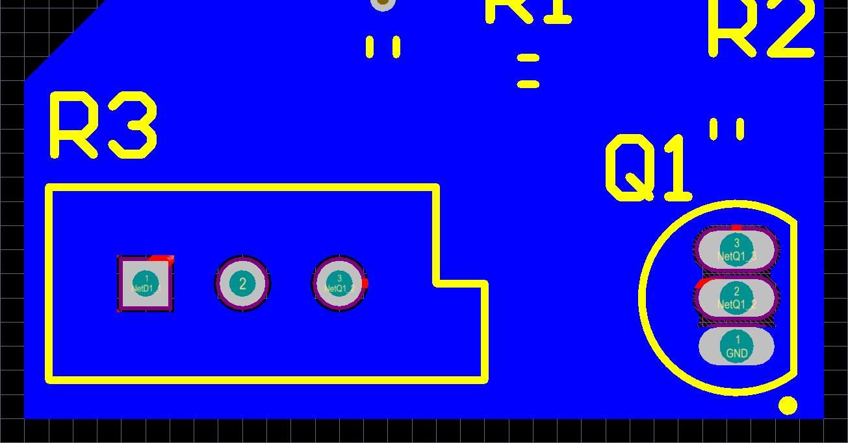

Problem 2 (7 pts):

Identify at least 3 potential health and safety hazards in the PCB manufacturing and assembly process.

Lead poisoning

Solder fumes

Gasses generated in pcb etchant are generally toxic

Problem 3 (6 pts):

What is flux and why should you use it when soldering?

Flux keeps an oxide layer from forming on the metals, allowing the solder to bond properly. Also, it makes the joints shiny.

Problem 4 (6 pts):

What is the primary benefit of using power and ground planes?

Ground planes can reduce noise by adding stray capacitances everywhere along the traces. Power planes can carry very high currents. Both planes increase routing convenience.

Problem 5 (6 pts):

What is thermal relief, and why is it important?

Thermal reliefs stop heat from escaping the pad while soldering, promoting shorter heat time therefore decreasing part failure from soldering. It also allow those without a metcal to solder the joint.

Problem 6 (30 pts):

Your company designs electronics for McDonald’s toys for children. Due to the nature of the product, you have an interesting design specification for failure rate which says that 90% of your circuits must be functioning after only a 6 month time span. This allows your company to take advantage of some very low cost, but very unreliable components. Your company has done testing with collections of high quality and low-quality components and has produced the following tables:

Cheap Components:

|  |  |  |  |  |
| --- | --- | --- | --- | --- |
| **Component** | **Quantity Tested** | **Test Period** | **# of Failures** | **Cost** |
| **Resistor** | 2000 | 2 years | 40 | $0.0005 |
| **Capacitor** | 1000 | 1 year | 15 | $0.001 |
| **LED** | 500 | 1 year | 5 | $0.03 |
| **Photodetector** | 200 | 1 year | 4 | $0.10 |

Expensive Components:

|  |  |  |  |  |
| --- | --- | --- | --- | --- |
| **Component** | **Quantity Tested** | **Test Period** | **# of Failures** | **Cost** |
| **Resistor** | 500 | 3 years | 5 | $0.02 |
| **Capacitor** | 1800 | 1 year | 10 | $0.005 |
| **LED** | 1000 | 2 years | 4 | $0.10 |
| **Photodetector** | 500 | 1 year | 5 | $0.18 |

You are designing a miniature toy lightsaber to promote a new Star Wars movie. The lightsaber is designed to sequentially illuminate 8 LEDs when someone gets close to it. To do so, the design uses a photodetector, 8 LEDs, 10 resistors, and 16 capacitors.

1. What is the average time to failure for building the design using cheap components?

FR = Failures/(devices*obs time)

|  |  |  |  |  |  |  |
| --- | --- | --- | --- | --- | --- | --- |
| **Component** | **Quantity Tested** | **Test Period** | **# of Failures** | **FR** | **QTY** | **FR * QTY** |
| **Resistor** | 2000 | 2 years | 40 | .01 | 10 | 0.1 |
| **Capacitor** | 1000 | 1 year | 15 | .015 | 16 | 0.24 |
| **LED** | 500 | 1 year | 5 | .01 | 8 | 0.08 |
| **Photodetector** | 200 | 1 year | 4 | .02 | 1 | 0.02 |

MTBF = 1/((10*.01)+(16*.015)+(8*.01)+.02)= 2.272727273 years

1. What is the average time to failure for building the design using expensive components?

|  |  |  |  |  |  |  |
| --- | --- | --- | --- | --- | --- | --- |
| **Component** | **Quantity Tested** | **Test Period** | **# of Failures** | **FR** | **QTY** | **FR * QTY** |
| **Resistor** | 500 | 3 years | 5 | 0.003333 | 10 | 0.033333 |
| **Capacitor** | 1800 | 1 year | 10 | 0.005556 | 16 | 0.088889 |
| **LED** | 1000 | 2 years | 4 | 0.002 | 8 | 0.016 |
| **Photodetector** | 500 | 1 year | 5 | 0.01 | 1 | 0.01 |

MTBF = 1/((10*.003333)+(16*.05556)+(8*.002)+.01) = 6.746626687 years

1. What percentage will be working after 6 months using exclusively cheap components?

E^(-0.5/2.2727) = 0.5599 -> 80.25%

1. What percentage will be working after 6 months using exclusively expensive components?

E^(-0.5/2.5465) =0.82178 -> 92.86%

1. How cheap can you make your design and still meet your requirements for 90% failure after 6 months? Show which parts you chose to implement with expensive or cheap components.

Code:

<https://pastebin.com/7k9Eeshf>

Description of code:

To optimize this problem, my program takes all the possibilities of combinations for the BOM, calculates the price and failure rate after 6mo, then finds the ones that meets criteria (>0.90) and minimizes price.

Problem 7 (15 points):

You are designing at PCB to measure the current to a remote-controlled car. Part of this PCB requires the use of a 0.05 Ohm shunt resistor where the voltage across the shunt can be used to determine the current. You shopped on Digikey and found the cheapest 0.05 Ohm shunts are $1.50 which are just too expensive, so you want to use a PCB trace to build a 0.05 Ohm shunt instead. Assuming 1 oz copper, how long would you need to make a 6 mil wide copper trace to function as a 0.05 Ohm shunt resistor. Give a reason why you might not want to use this approach to get an accurate current measurement?

R= Pcopper*(L/(T*W))*(1+acopper*(temp-25))

Pcopper=resistivity, 1.7e-5 ohm-mm

L= length(unknown)

T=trace height, 1oz=0.0348mm

W=trace width, 6mil=0.1524mm

Acopper=temp coeff, 3.9e-3 ohm/ohm/C

L = 15.598588mm

Although doable, a shunt using copper traces is highly inaccurate, as PCB fabs don’t generally have to conform to a tight copper layer thickness requirement. Metals also change their resistance coefficient (pcopper) greatly with temperature change. The signal quality also not might be very good, as more than likely there will be capacitive and inductive loading occurring.

Problem 8 (20 pts):

Describe a situation where you might wish to use a Colpitts oscillator instead of a Pierce oscillator. (5 pts)

A Colpitts oscillator, although more prone to jitter, uses a lot less power than a pierce oscillator.

You are shopping around for an 8 MHz crystal and find one with the following data sheet:

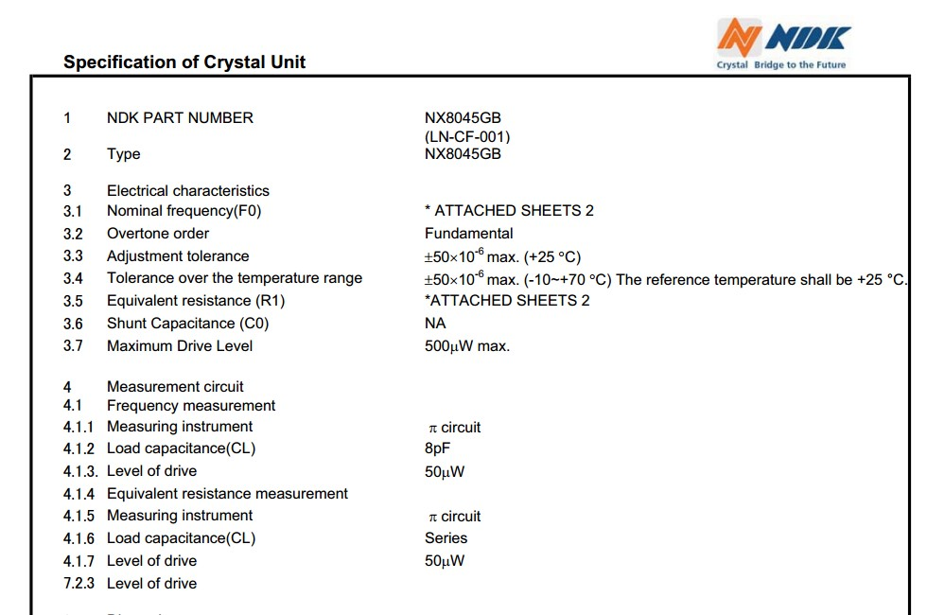

What value of capacitor would you use for your tuning capacitors? (5 pts)

8pF

For a pierce:

Ctotal = (C1C2)/(C1+C2)

The capacitor should be 16pF, as (16*16)/(16+16) = 8

If you used the crystal above as a clock for a watch, what is the maximum number of seconds you would expect the watch to be off by after a decade? (10 pts)

10yr*365days*24hrs*3600s*50*10^-6=15768 seconds=4.38 hours

Problem 9 (10 pts):

You are an engineer tasked with developing a keychain Bluetooth tracking tag. Your tag will be sold in Europe which has laws against engineered obsolescence. In your design process you find you can select hardware that with the appropriate software can allow your tag to function for 10 years on a single nonreplaceable battery. Upon hearing the “good” news, your manager says that corporate was hoping not to achieve more than a 4-year lifespan so as to limit the number of old devices still in operation in the future. Which of the following is the LEAST plausible justification you could bring to your manager to push back against this directive?

1. LEGAL: The sale of this device in a country that prohibits engineered obsolescence prevents you from deliberately engineering the product that dies prematurely.
2. ENVIRONMENTAL: Producing very similar electronics on a large scale that have a longevity of 4 years instead of 10 will more than double the amount of electronic waste produced from the product.
3. SAFETY: A design that drains a coin-cell battery in 4 years instead of 10 will produce more heat from the increased energy usage that could burn someone’s leg if in their pocket.
4. SOCIETAL: Tracking tags that stop functioning more often will increase the chances people rely on a tracking device that is no longer functioning, leading to unnecessarily lost keys and an increase in associated disruptions to daily life.